
Training Report

THE COLOMBO PLAN DRUG ADVISORY PROGRAMME
Training Report

Description
  - Training Name :Universal Treatment Curriculum 02, Treatment for Substance Use Disorder- The Continuum of Care for Addiction Practitioners
  - Locations (Country & Regions) :(Virtual via Zoom) ITRAMIC Foundation Office
Pakistan Lahore
  - Education Provider Name :ITRAMIC Foundation
  - Start and end date of the Training :19th to 28th February 2022
  - Names of Resource Personnel : Dr. Muhammad Amjad Chaudhry,
- Introduction:
In order to endorse the evidence-based practices in the field of addiction treatment in Pakistan, ITRAMIC Foundation Lahore organized virtual training for treatment staff and professionals from 19th to 28th February 2022. The training was imparted on the following curriculum:

- Curriculum 02: Treatment for Substance Use Disorder- The Continuum of Care for Addiction Practitioners
The following Pakistani National Trainers facilitated the training:
- Dr. Muhammad Amjad Chaudhry
- Lt. Col. (R) Dr. Nadeem Ahmed Bajwa
- Ms. Nazia Bashir

- Objective of the Training Program:
The objectives of the training program were to train local addiction treatment professionals with up-to-date their knowledge for evidenced-based practices in addiction treatment and empower them to integrate new practices into their treatment facilities. Following specific objectives were focused for the training on each curriculum.

Objectives of the Course on UTC 2:
- Try to make the participants to learn about recovery.
- To elaborate the significance of continuum of care
- To discuss the motivational approaches and their role in recovery.
- To learn about recovery capitals.
- To acquire about evidence Based practices.
- How Multiple Therapies van be beneficial in recovery.

- Description of the Training:
The training was kicked off by the Chairman ITRAMIC Foundation Dr. Muhammad Amjad Ch. at 04:30pm on zoom. He welcomed the distinguished guest and all the participants. He explained the objective of this training series and dwelt light on the significance of these trainings in Pakistan. After his introduction, Mr. Muhammad Ayub from Drug Advisory Programme greeted all the trainers and participants and appreciated this initiative taken by ITRAMIC FOUNDATION and CP-DAP. After his speech trainers and participants introduced themselves and their organizations and training was formally started.

Whole Training was covered by three trainers. All of trainers tried to achieve their goal to educate the participants with the new trends of treatment defined in Curriculums.
For covering Curriculum 2, Trainers Dr. Amjad Chaudhry, Lt. Col. (R) Dr. Nadeem Ahmed Bajwa and Ms. Nazia Bashir put their best efforts to share their knowledge and lead healthy discussions during their presentations. The stages of change, motivational therapies, and evidence based practices in Pakistan and Pharma co-therapy was the hot issue for discussion in the training. The training on curriculum was structured as per the UTC Agenda. During the trainings, the participants demonstrated particular interest in training methodology and virtual training exercises.
During the closing ceremony the participant were excited on the fulfillment of their Training and excited for next phase. Mr. Muhammad Ayub from Drug Advisory Programme Colombo Plan and Mr. Afeef Siddiqi Chairman Local Government Affairs Committee Lahore Pakistan graced the closing ceremony.

- List of Participants:

Serial No. | Full Name | Email Address | Organization/ Location | Designation
01 | Dr. Muhammad  Yaqoob | dryaqoob99@gmail.com | Sargodha | Head of Department
02 | Dr M.Akif Saeed CH. | drmuhammadakif8@gmail.com | Self Employed  Faisalabad | General Physician
03 | Aleena Safdar | aleenasafdar230@gmail.com | Devotion Rehabilitation Centre Rawalpindi | Clinical Psychologist
04 | Dr. Aamir Mirza | mdpsycho123@gmail.com | Solace Rehab  Lahore | CEO
05 | Dr. Inayatullah Magsi | i_magsi1@yahoo.com | Chandka Medical College  Larkana | Assistant Professor
06 | Asma Khawaja | usaa2007@gmail.com | Khalida Memorial Hospital Sialkot | Addiction Treatment Counselor
07 | Dr Filza Bashir | filzabashir153@gmail.com | Islamabad | Studying
08 | Munawar Ahmad | attari3288674@gmail.com | Umeed Clinic | Manager
09 | Humaira Rashid | humairarashid@live.com | Self Employed | Teaching
10 | Akhtar Hussain | akhtarcompass95@gmail.com | Umeed Clinic Lahore | Trainee Psychologist
11 | Humaira Majeed | humairagansari4@gmail.com | Help Autism Pakistan | ABA Therapist
12 | Qurat ul ain Sammar | sammarkhan244@gmail.com | GCMS | Clinical Psychologist
13 | Abdul Munir ansari | muniransari549@gmail.com | Azad Welfare Foundation | Secretary Studying Circle
15 | Muhammad Ishaq | ishaqlang@yahoo.com | Life Drug Addiction Treatment Centre Lahore | Psychologist
16 | Zeeshan Anjum Ch. | zeeshananjum.psy@gmail.com | Qanmos Institute of Mental Health Services Lahore | Head of Department

- Pre- and Post-Test Scores of the Participants:

Sr # |  |  | nn Name nFull Name |  |  | Pre Test |  | Score % |  | Post Test |  |  | Score %
 |  |  | Dr. Muhammad  Yaqoob |  |  | 05 |  | 25% |  | 16 |  |  | 80%
 |  |  | Dr M.Akif Saeed CH. |  |  | 09 |  | 45% |  | 14 |  |  | 70%
 |  |  | Aleena Safdar |  |  | 10 |  | 50% |  | 10 |  |  | 50%
 |  |  | Dr. Aamir Mirza |  |  | 07 |  | 35% |  | 14 |  |  | 70%
 |  |  | Dr. Inayatullah Magsi |  |  | 11 |  | 55% |  | 15 |  |  | 75%
 |  |  | Asma Khawaja |  |  | 11 |  | 55% |  | 16 |  |  | 80%
 |  |  | Dr Filza Bashir |  |  | 13 |  | 65% |  | 14 |  |  | 70%
 |  |  | Munawar Ahmad |  |  | 18 |  | 90% |  | 18 |  |  | 90%
 |  |  | Humaira Rashid |  |  | 05 |  | 25% |  | 15 |  |  | 75%
 |  |  | Akhtar Hussain |  |  | 06 |  | 30% |  | 16 |  |  | 80%
 |  |  | Humaira Majeed |  |  | 06 |  | 30% |  | 11 |  |  | 55%
 |  |  | Qurat ul ain Sammar |  |  | 12 |  | 60% |  | 16 |  |  | 80%
 |  |  | Abdul Munir ansari |  |  | 05 |  | 25% |  | 03 |  |  | 15%
 |  |  | Muhammad Ishaq |  |  | 04 |  | 20% |  | 09 |  |  | 45%
 |  | Zeeshan Anjum Ch. |  |  |  | 04 |  | 20% |  | 05 |  |  | 25%
 |  |  |  | Mean Score | Pre Test |  | 8.63 |  | Post Test |  | 12.64
 |  |  |  | Highest Score | Pre Test |  | 18 |  | Post Test |  | 18
 |  |  |  | Low Score | Pre Test |  | 04 |  | Post Test |  | 03

- Training Evaluation Data:

Item | Overall Training Feedback | Agree  % | Neutral  % | Disagree  %
1 | The training objectives are clearly stated and measurable | 100% | 0% | 0%
2 | The course content is consistent with the training objectives and outcomes | 92.9% | 7.1% | 0%
3 | The course content provides substantial up to date information | 100% | 0% | 0%
4 | The course content is relevant to my work | 92.9% | 7.1% | 0%
5 | The number of modules is sufficient to achieve the objectives of the course | 77% | 23% | 0%
6 | The sequence of the modules are organized and easy to follow | 100% | 0% | 0%
7 | The training methodologies used promote maximum learning experience | 92.9% | 7.1% | 0%
8 | The training activities reinforce the learning of important concepts | 92.9% | 7.1% | 0%
9 | Training approach is well-balanced in terms of contents, activities, and interaction | 92.9% | 7.1% | 0%
10 | The time allotted is sufficient to cover the topics and exercises in the module | 92.9% | 7.1% | 0%
11 | Sufficient time is allotted to accommodate trainees’ inquiries | 92.9% | 7.1% | 0%
12 | Training materials are adequate and useful | 92.9% | 7.1% | 0%
13 | The illustrations use is relevant and reinforce important concepts | 92.9% | 7.1% | 0%
14 | The graphics are culturally appropriate | 92.9% | 7.1% | 0%
15 | The training venue is conducive for learning | 100% | 0% | 0%

Overall Training Evaluation

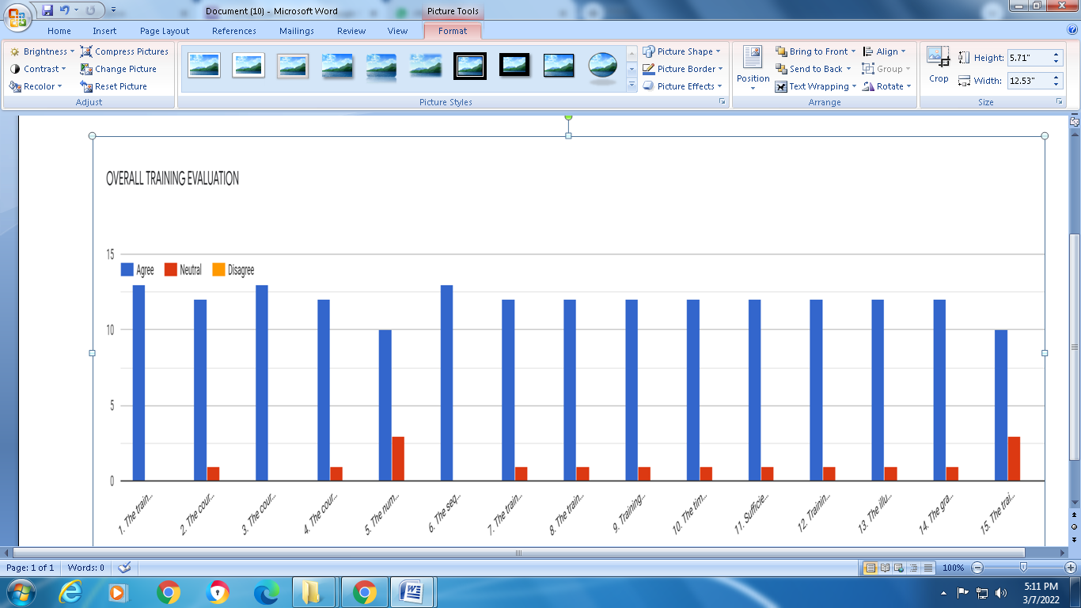

Trainers’ Evaluation

Trainer Name Dr. Muhammad Amjad Chaudhry
No | Criteria | Developing | Adequate | Adequate Proficiency | Proficient
1 | Knowledge of the Subject Matter  + | 0% | 15.5% | 15.5% | 69%
2 | Participant Engagement | 0% | 8% | 23% | 69%
3 | Supervision of Training Environment | 0% | 15.5% | 15.5% | 69%
4 | Time Management | 0% | 8% | 23% | 69%
5 | Demeanour | 15% | 8% | 15% | 62%

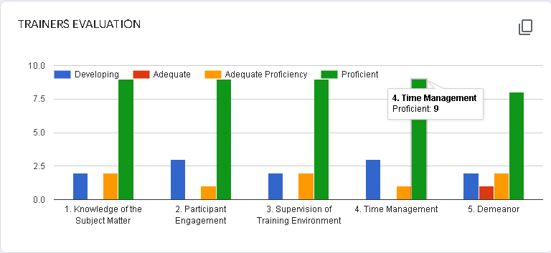

Trainer Name: Lt. Col. (R) Dr. Nadeem Ahmed Bajwa
No | Criteria | Developing | Adequate | Adequate Proficiency | Proficient
1 | Knowledge of the Subject Matter | 21.4% | 0% | 0% | 78.6%
2 | Participant Engagement | 7.1% | 14.3% | 14.3% | 64.3%
3 | Supervision of Training Environment | 0% | 14.3% | 14.3% | 71.4%
4 | Time Management | 21.4% | 0% | 7.1% | 71.4%
5 | Demeanour | 14.3% | 7.1% | 7.1% | 71.4%
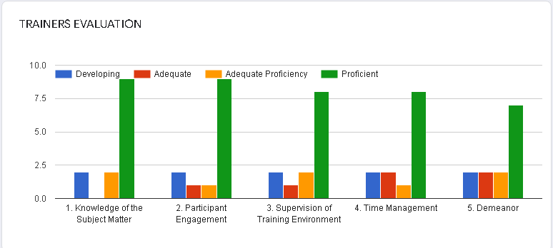

Trainer Name: Ms. Nazia Bashir
No | Criteria | Developing | Adequate | Adequat  Proficiency | Proficient
1 | Knowledge of the Subject Matter | 15.5% | 23% | 7.5% | 54%
2 | Participant Engagement | 30.8% | 7.7% | 0% | 61.5%
3 | Supervision of Training Environment | 23% | 7.7% | 7.7% | 61.5%
4 | Time Management | 23% | 8% | 15% | 54%
5 | Demeanour | 23% | 15.5% | 15.5% | 46%

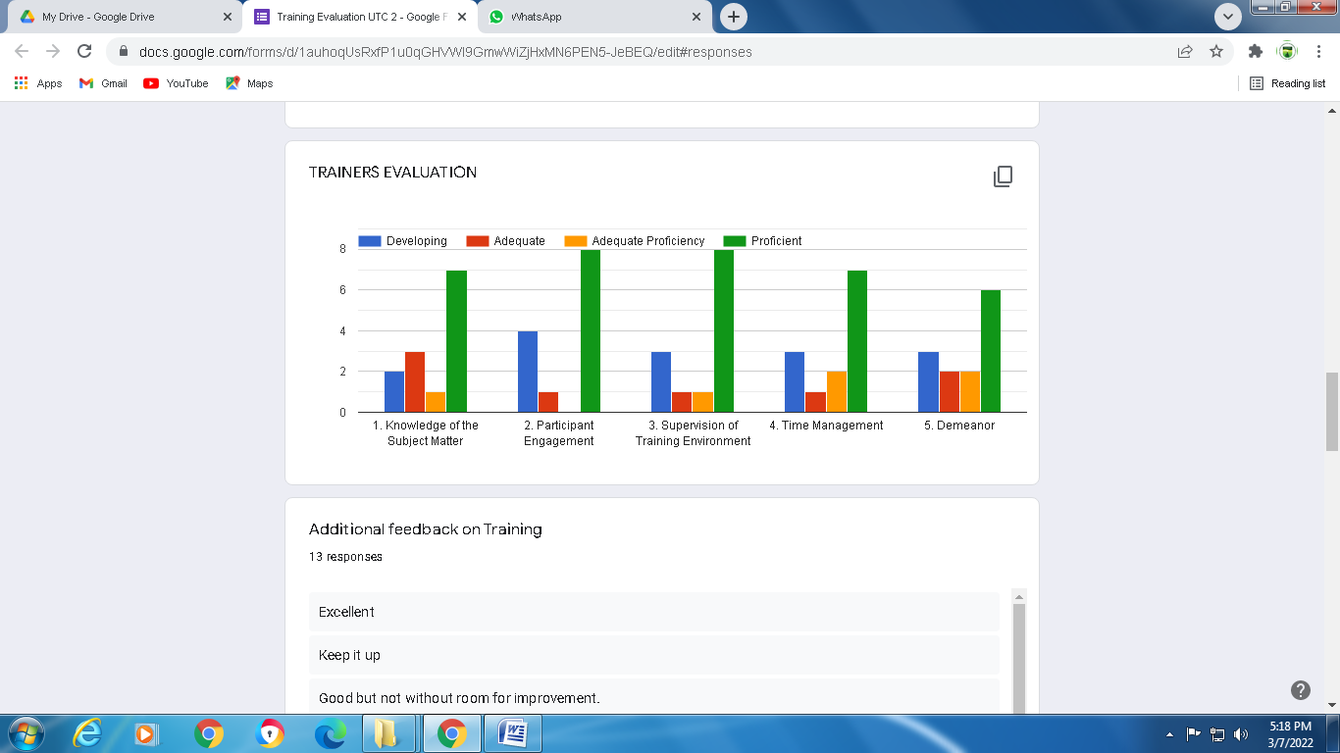

- Reflections of the Participants:
- “It was very skillful evidence based training. I learnt very much about Substance Use Disorder from this training.” Dr. Muhammad Yaqoob Professor of Peads, Head of Department Rai Medical College Sargodha, Punjab Pakistan.
- “It was good and very informative training for us regarding evidence based training, we learned lot of things from our outstanding trainer specially Dr.Muhammad Amjad and others. Thanks to everyone for cooperation.” Dr. Inayatullah Magsi Assistant Professor Chandika Medical College Larkana, Sindh Pakistan.
- “Training was very useful and informative. Trainers were excellent will highly recommend this training to anyone who is interested in learning SUD and its treatment”. Ms. Qurrat ul Ain Sammar, Clinical Psychologist, GCMS Abbotabad, KPK Pakistan.

- Challenges
[List of potential risk and challenges encountered while organizing and during the training program and actions taken]

- Recommendations and Participants Comments on the Training:
- Should continue such training in future
- Training was very useful and informative.Trainers were excellents will highly recommend this training to anyone who s interested in learning Sud and its treatment.
- Waiting for another training with these trainer
- Trainer are very much passionate & devoted to teach knowledge.
- wonderful experience of learning
- It was a great learning experience, looking forward to have more such trainings
- Training professional Dr amjid shb & Dr NADEEM shb doing great job
- Outdtanding traning
- Good job
- Training was good and well managed
- Please inform me for training next time.
- Internet connectivity remained issue.

12. Visibility Materials (photos, videos, articles, leaflets, print materials, paper article or any success story):
Opening Ceremony

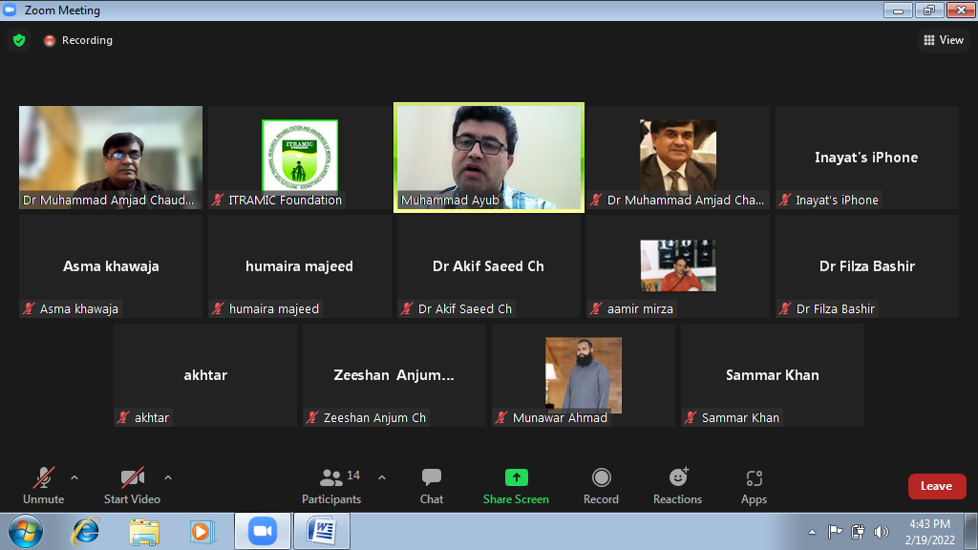

During the Sessions

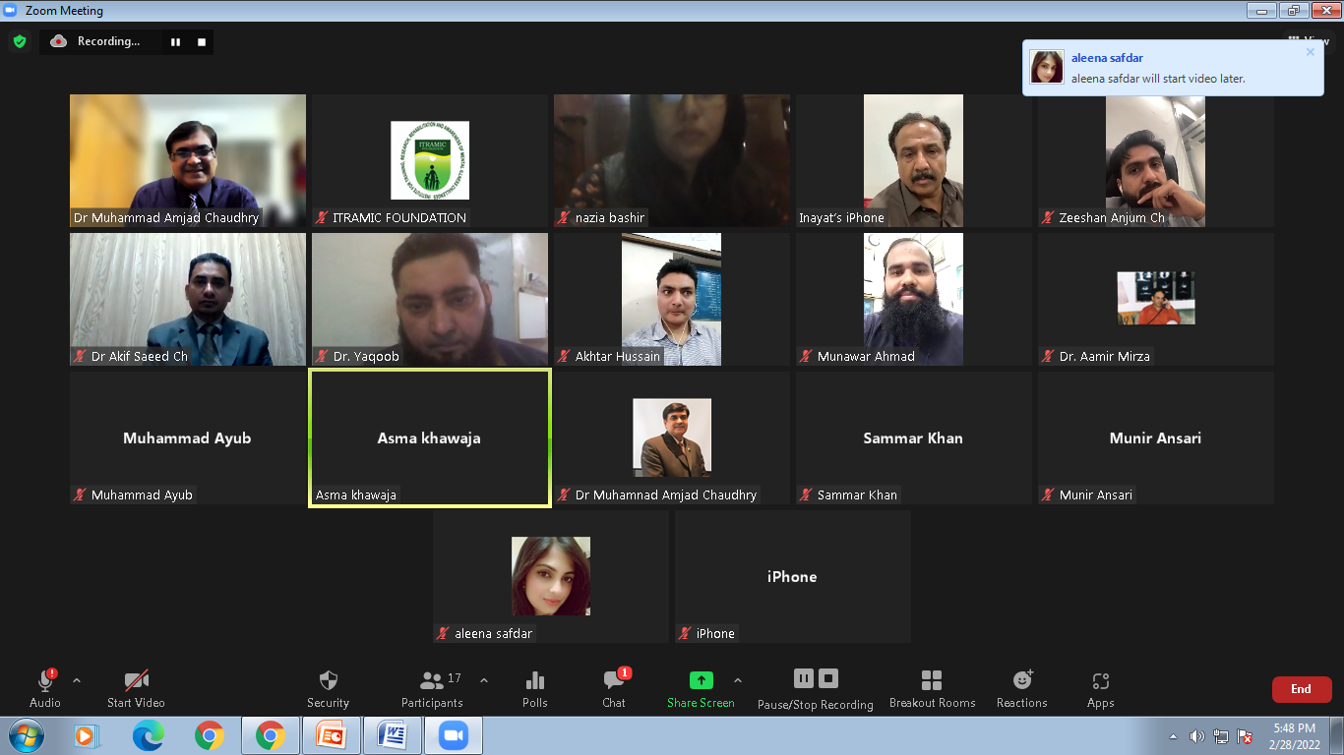
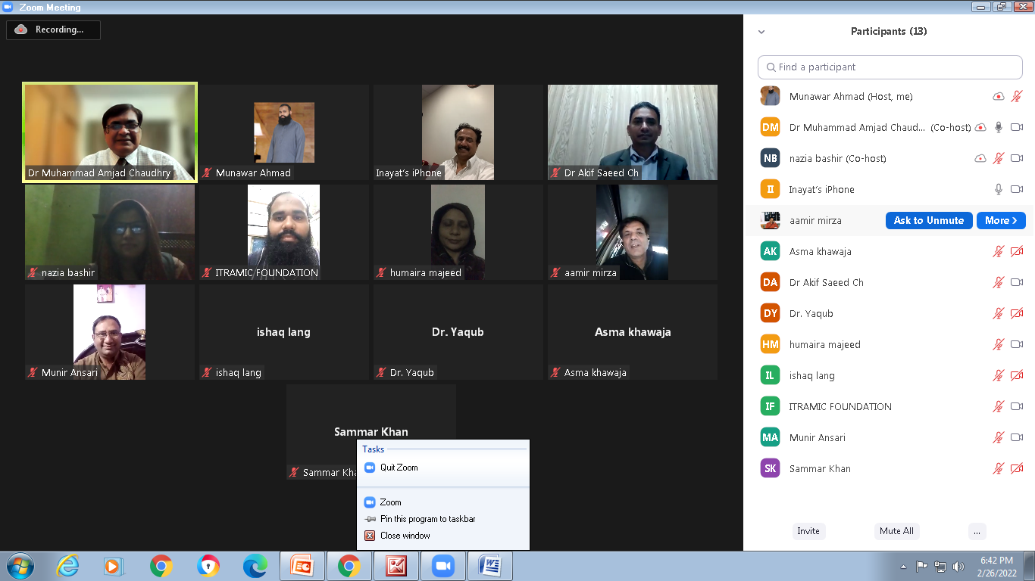
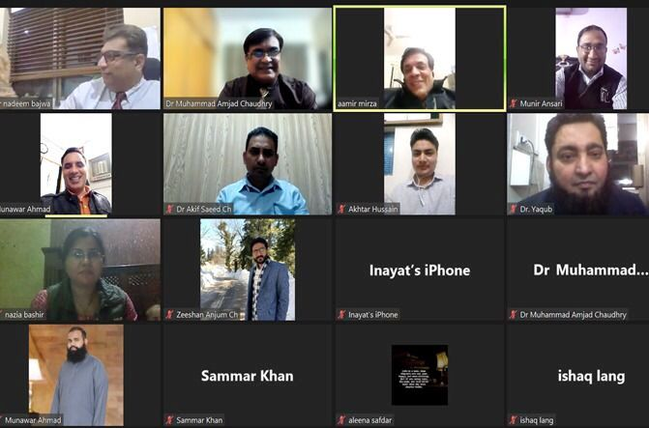
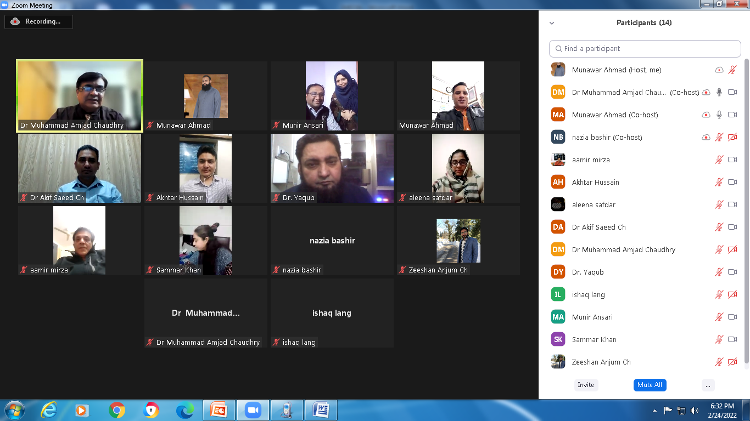

Closing Ceremony

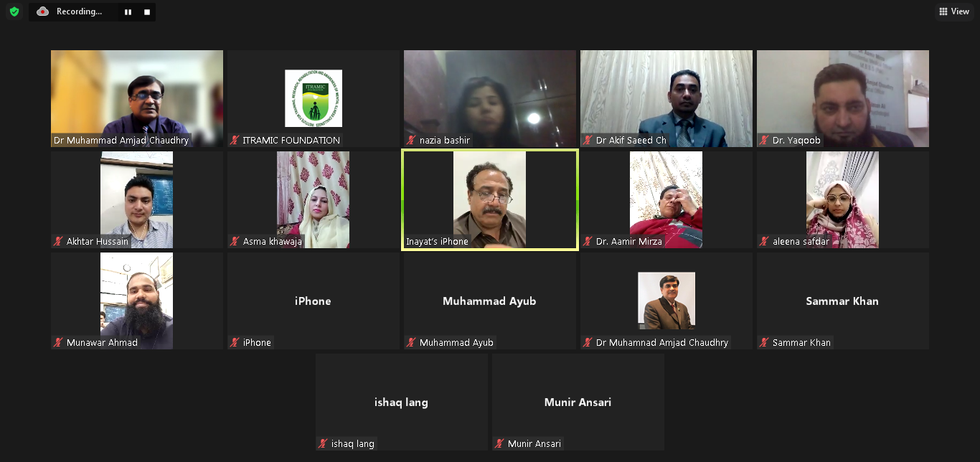
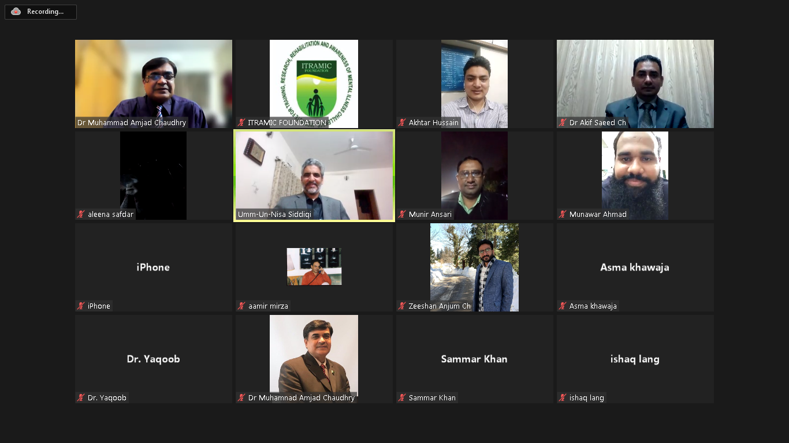

- Prepared by (with Signatures)
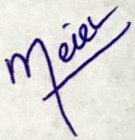
Munawar Ahmad
Finance Secretary
ITRAMIC Foundation
Training Coordinator

